Appendix 1

Annual Equality in Employment

Monitoring Report

2017 – 2018



Introduction

Harrow prides itself in being one of the most ethnically and religiously diverse boroughs in the country with people of many different backgrounds and life experiences living side by side. It is the richness of this diversity, and the positive impact that it has on the borough and our community, that we believe helps make Harrow such a great place to live, work and visit.

Our equalities vision is ‘A Proud, Fair & Cohesive Harrow, a Great Place to Live, Work & Visit’ and one of our strategic equality objectives is to develop ‘An inclusive workforce that feels valued, respected
and reflects our community’.

This report sets out information on Harrow Council’s performance on equalities and the impact of its policies and practices on its employees. It reviews the employment data to comply with the human resources requirements of the Public Sector Equality Duty set out in the Equality Act 2010 and the Equality Act 2010 (Specific Duties) Regulations 2011.

The full report will be published separately. This report comprises of the employee equalities data summarised by protected characteristic, for the year ending 31 March 2018 and a brief analysis of the data which highlights key issues arising from the equalities data. The summary will be considered by the Corporate Equalities Group (CEG) and any issues identified from the analysis of the data will be addressed in the 2019/20 Corporate Equalities Action Plan.

Note: Tables with all equalities figures relating to 2017/18 broken down by Services and Harrow Council (including Schools) can be found in Appendix 2.
Data Notes

Workforce Profile Data

This report provides a profile of Harrow Council’s non-schools workforce demographics. It also excludes contracted out services which are monitored elsewhere. The report brings together data taken from the council’s HR and payroll systems and job applicant diversity records for the period of 1 April 2017 to 31 March 2018.

Note: Tables with all equalities figures relating to 2017/18 broken down by Services and Harrow Council (including Schools) can be found in Appendix 2.

The Workforce Profile is a snapshot of the workforce as at 31 March 2018, broken down by the protected characteristics, by pay band and whether Full or Part-time. There is no requirement to report on Marital Status but this has been included this year in data in Appendix 2.

The report is based on headcount, therefore, an employee who holds jobs in more than one directorate will be counted only once in the whole council report, but will appear in each of the Directorate reports. In determining which job to count for the whole council report, the job with the highest number of working hours is used.

Data Sources and Comparison with the Community

Data used for comparison with the community was obtained from 2011 Census Briefing. Note 11: May 2013 - Gender, Age, Religion and Health, by Ethnic Group 2011 Census, Third Release (3.1). Gender and Age data has been updated in line with 2014 Mid-Year Estimates.

Recruitment

These figures cover recruitment for posts where processed by Pertemps. As Schools do not use Pertemps, data relating to their recruitment is not available in this report.
Definition of Terms

20

Applicants | Number of applicants who applied for roles within Services
Shortlisted | Number of applicants who were shortlisted for roles within Services
Appointed | Number of applicants who were appointed to roles within Services
Salary Bands | Harrow Council pay scales grouped into bands
 | Band 1 | G1 to G3
 | Band 2 | G4 to G8
 | Band 3 | G9 to G11
 | Band 4 | MG1 – MG3
 | Band 5 | MG4 and D1
 | Band 6 | D2 and above
BAME | Includes Asian, Black, Mixed or any other minority ethnic group
Working Pattern | Employees that are either Full Time or Part Time
LGBTQ+ | Includes Lesbian, Gay Men, Bisexual, Trans, Questioning and Other

Key Findings

- The number of staff who have identified themselves as BAME across the organisation has risen marginally. This still remains below the community census data we hold from 2011 but we do not know how this compares to the current community demographic

- There has been a small reduction in the percentage of staff declaring a disability

•

The percentage of our workforce which is female, is over 25%higher than the borough population

- The number of ‘unknown’ has fallen against ethnicity, disability, religion or belief and sexual orientation. This is due to the SAP system being updated last year which now allows to staff to log or update equality data themselves. We continue to communicate this through the organisation and strive to improve the quality of diversity data

- The % of staff declaring their sexual orientation remains low at 41%

- The % of staff declaring their religion or belief also remains low at 42%

- There is still a disproportionate amount of women and staff from BAME in the highest two pay bands representing 107 staff in comparison to the make-up of the workforce as a whole. This continues to be an action on the annual equalities action plan

Trends at a glance

No of

Employees

Age Group

Disability

BAME

Female

LGBTQ

2015 | 2016 | 2017 | 2018
2042 | 2028 | 2052 | 2015
32.62% | 30.82% | 29.29% | 27..99%
45 - 54 | 45 - 54 | 45 - 54 | 45 - 54
2.94% | 2.91% | 4.53% | 4.12%
40.16% | 42.01% | 42.54% | 43.23%
61.51% | 61.74% | 61.45% | 61.79%
0.78% | 0.93% | 1.08% | 1.20%

Decrease in employees

Highest % age group remains the same

Decrease in employees declaring a disability

Increase in employees declaring BAME origin

Increase in female employees

Increase in LGBTQ

Age of our workforce

Our percentage employees aged 16 – 34 has increased since last year and now comprise 17.96% of the workforce

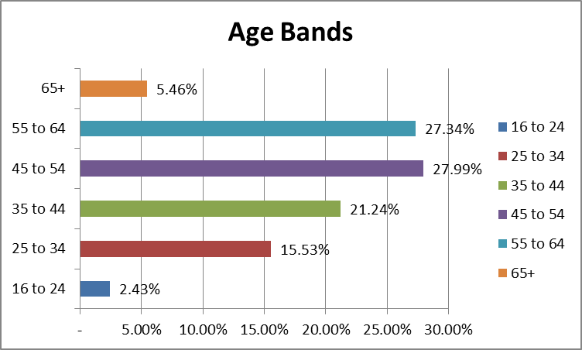

The average age of Council staff is:
47.4

Age of our workforce

Age by Salary Band

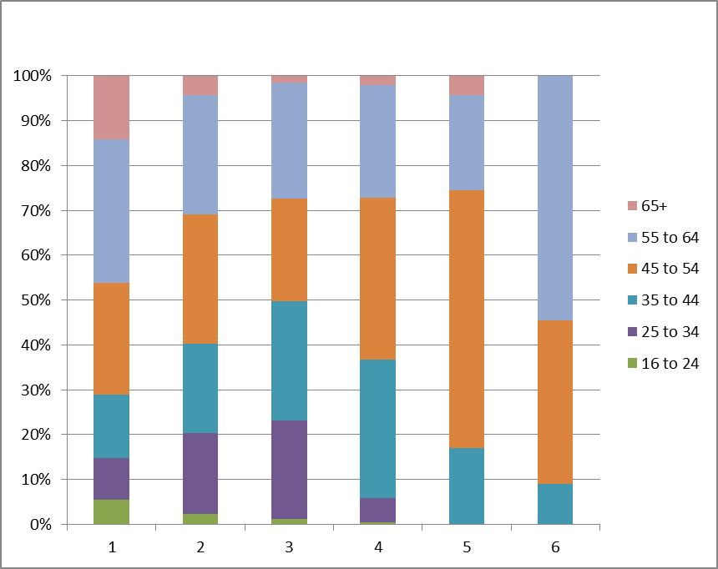

Age by Salary Band
Disability

4.12% of the workforce have declared they
have a disability.
46.60%

This decreased by 0.41% from the 2017

equalities report.
49.28%

Yes No Unknown
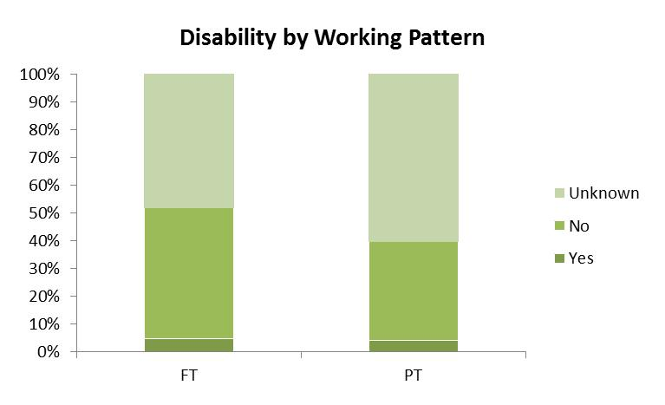

Disability by Salary Band

100%
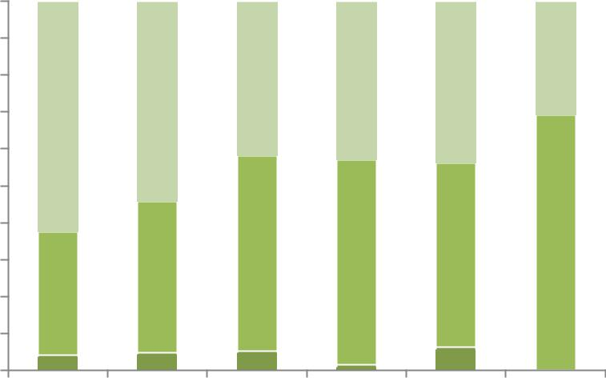

90%

80%

70%

60%

50%

40%

30%

20%

10%

1 2 3 4 5 6

Unknown

No

Yes

Work / Life Balance (Maternity)

92 employees were on maternity leave in 2017 – 18

79% returned to their roles, however 7.60% left the organisation within 4 months

Maternity Returners by Pay Band
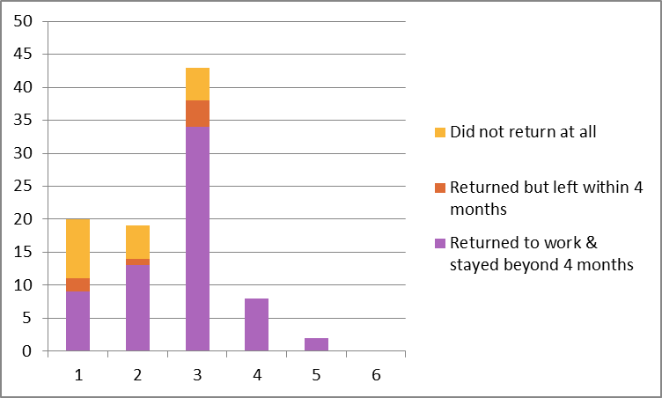
Ethnicity

43% of our workforce identified themselves as BAME
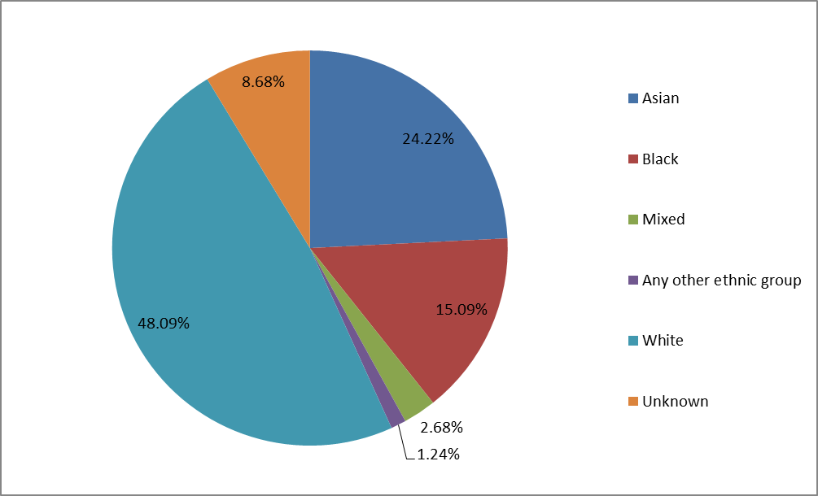
Ethnicity

Ethnicity by Salary Band
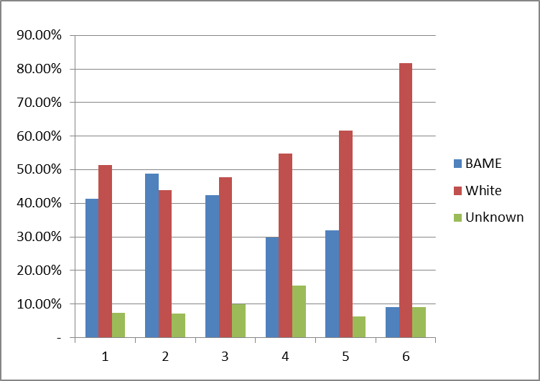

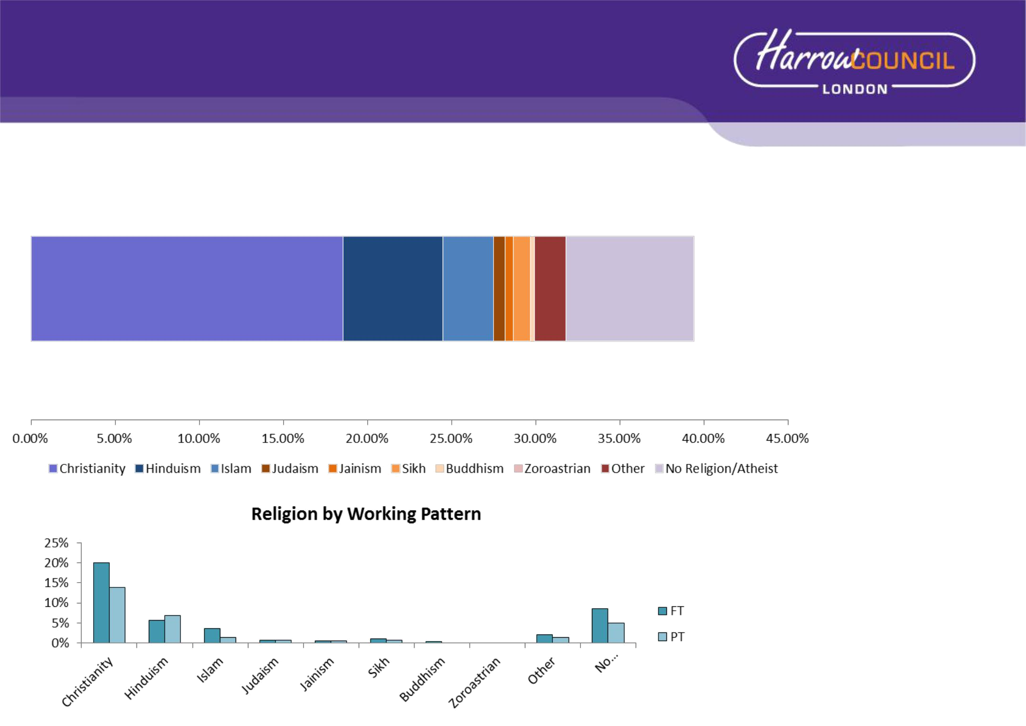
Religion or Belief

42.38% of the workforce

have declared their religious beliefs

We still do not know the religion or

beliefs of almost 58% of the workforce. A marginal improvement of 2% compared to last year,

The percentages in the bar chart show the working patterns of employees by Religion

Note: The graphs relating to religion only shows a breakdown of those who have declared their religion or belief and excludes ‘unknown’

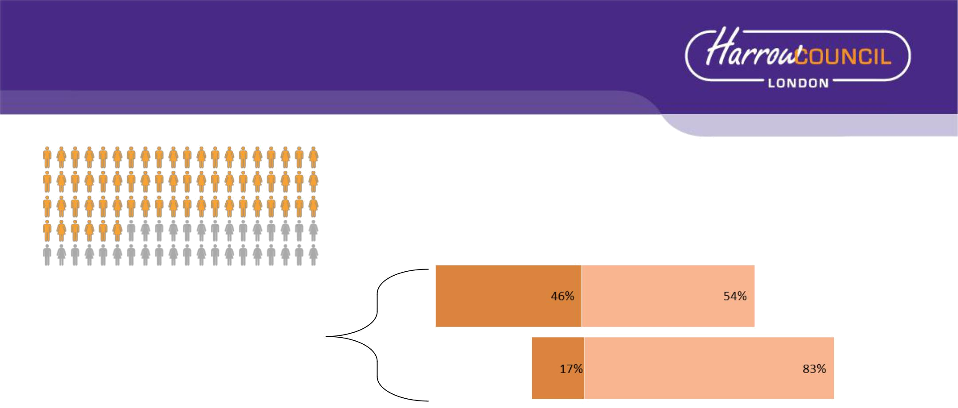
Gender

61.79%

female.

The workforce by gender and
their working patterns

Gender by Salary Band

100.00%
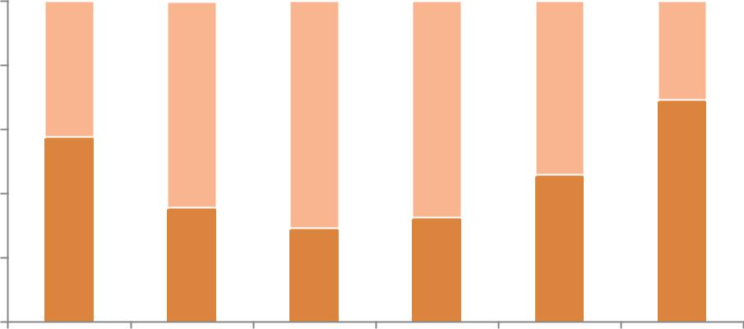

80.00%

60.00%

40.00%

20.00%

0.00%

1 2 3 4 5 6

Male Female

of the workforce are

Full Time

Part Time



The Harrow Community Census 2011 stated 50.30% of our community were female, which means our

workforce is currently has 11.49% higher female presence
Sexual Orientation

1.19% of our workforce have declared themselves to be LGBTQ. In 2017-18 we dropped one place from 153 to 154 in the Stonewall Workplace Equality Index. The sexual orientation of 61% of Council staff is unknown.

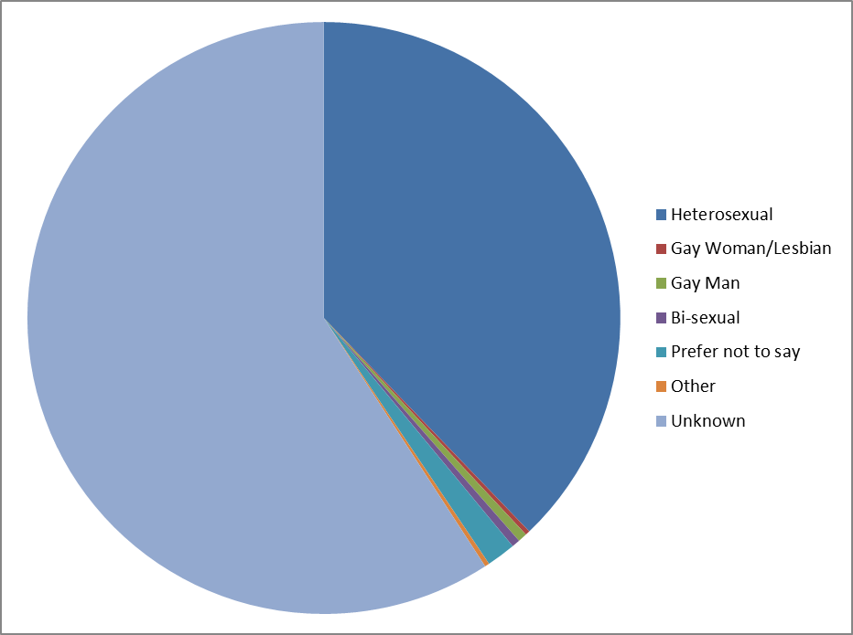

Recruitment and Leavers

Disability

Recruitment: There were 3080 applicants for roles advertised with Harrow Services in 2017 – 2018 and increase from 2657 in 2016-17. Of these candidates 1.59% declared a disability, a slight decrease from 2016-17 (1.62%).

The percentage of candidates shortlisted has increased from 1.23% to 2.39% but the number of disabled candidates has slightly decreased from 1.78% to 1.65%.

 |  | Applied |  | Shortlisted |  | Appointed
 |  | (3080) |  | (836) |  | (242)
 |  | Nos. | % | Nos. | % | Nos. | %
 | Yes | 49 | 1.59% | 20 | 2.39% | 4 | 1.65%
Disability | No | 2879 | 93.47% | 772 | 92.34% | 229 | 94.63%
 | Prefer not to say | 152 | 4.94% | 44 | 5.26% | 9 | 3.72%

Leavers

There were 18 leavers in 2017-18 compared to 10 in 2016-17. Of these leavers 9 were over 60 and left due to retirement and ill health retirement. No trend identified.

Recruitment - Gender

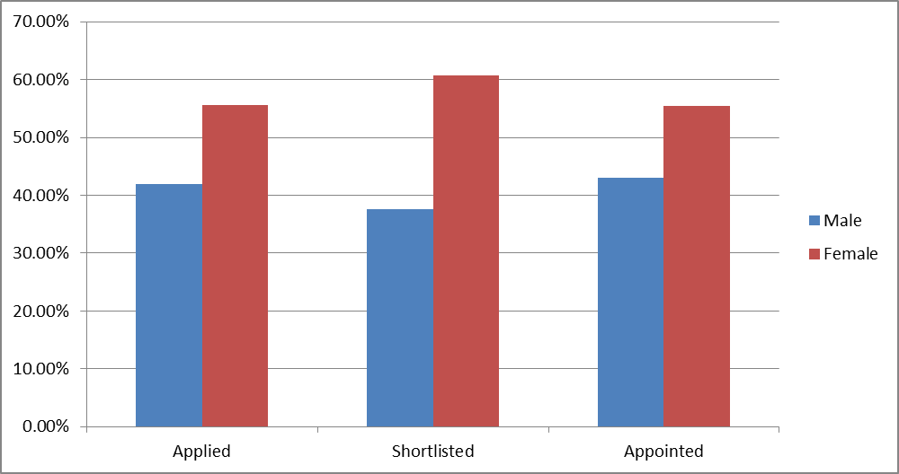
Leavers by gender and length of service
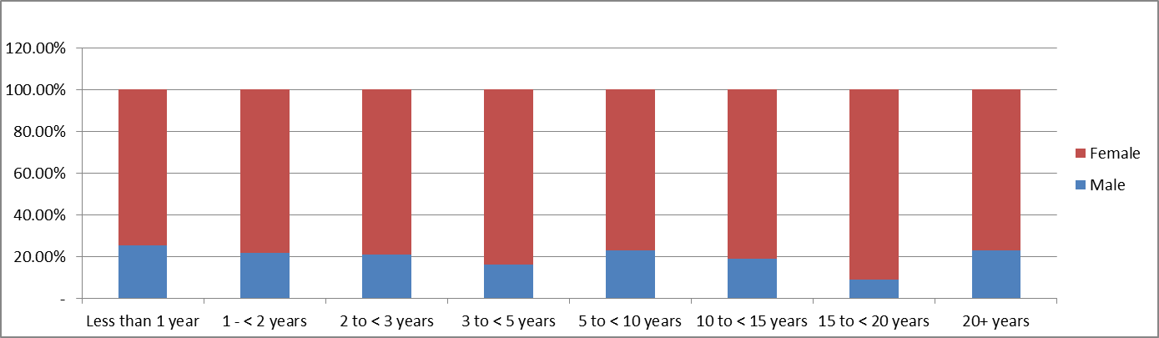

Recruitment - Ethnicity

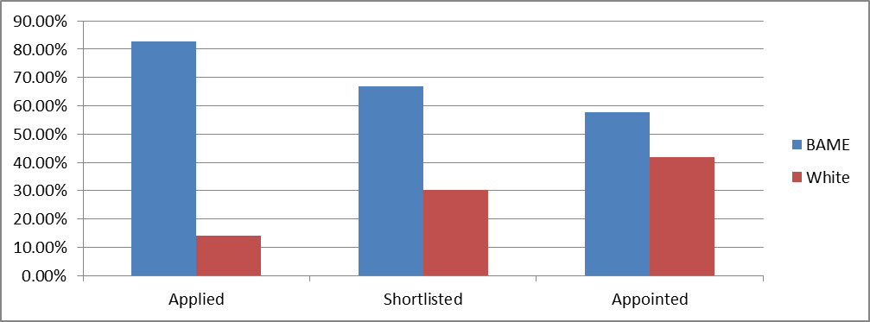
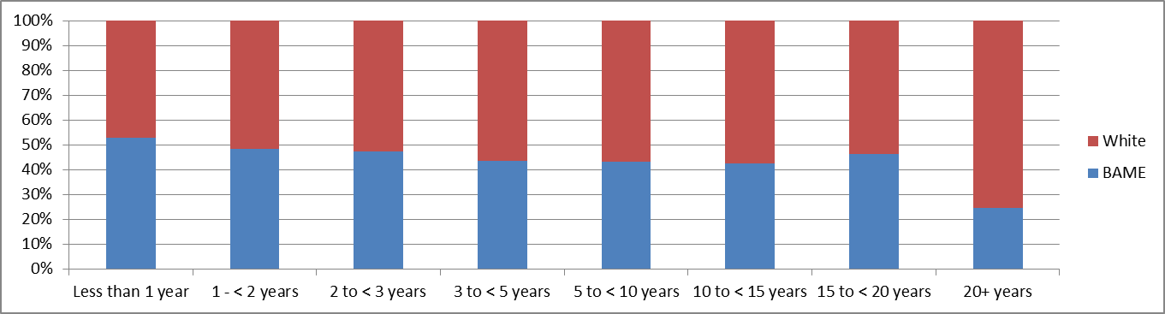 |  | Leavers broken down by ethnicity and length of service

